LOGIC BUILDING WITH LOOPS
(BEFORE STARTING DSA)

Phase 1 – While Loop
Phase 2 – do while loop
Phase 3 – For Loop
Phase 4 – Nested loop Logic
Phase 5 – Break / Continue logic
Phase 6 – Mathematical Series
Phase 7 – Mixed Logical Loop Problems
Phase 8 – Star Pattern Printing

Goal: Master loops, iteration, and dry-run thinking.
Topics covered: while, do-while, for, break, continue,mathematical series. Target Questions: 125+

Phase 1 : While Loop
- Print all numbers from 1 to 10 using a loop.
- Print numbers from 10 down to 1 in reverse order.
- Print all even numbers between 1 and 100.
- Print all odd numbers between 1 and 100.
- Print the multiplication table of a given number from n × 1 to n × 10.
- Calculate and print the sum of the first n natural numbers.
- Calculate the sum of all even numbers from 1 up to n.
- Calculate the sum of all odd numbers from 1 up to n.
- Calculate and print the factorial of a given number.
- Find and print the product of all digits of a given number.
- Count and print the total number of digits in a given number.
- Reverse the given number and print the reversed value.
- Check whether the given number is a palindrome.
- Find and print the sum of digits of the given number.
- Check whether the given number is an Armstrong number.
- Check whether the given number is a Perfect number.
- Print all prime numbers between 1 and 100.
- Check whether the given number is a prime number.
- Print the Fibonacci series up to n terms.
- Find and print the sum of the Fibonacci series up to n terms.
- Print the square of each number from 1 to n.
- Print the cube of each number from 1 to n.
- Print all numbers between a and b that are divisible by 7.
- Print all factors of the given number.
- Find and print the sum of all factors of the given number.
- Find the HCF (Highest Common Factor) of two given numbers.
- Find the LCM (Least Common Multiple) of two given numbers.
- Find the smallest digit in the given number.
- Find the largest digit in the given number.

Phase 2 : do - While Loop
- Print all numbers from 1 to 10.
- Print the multiplication table of a given number.
- Keep taking numbers from the user until 0 is entered, then print the sum of all entered numbers.
- Keep taking numbers from the user until 0 is entered, then print the largest number among all inputs.
- Count and print the number of digits in the given number.
- Reverse the given number and print the reversed value.
- Check whether the given number is a palindrome.
- Check whether the given number is an Armstrong number.
- Calculate and print the factorial of the given number.
- Print the Fibonacci series up to the required number of terms.
- Find the HCF (Highest Common Factor) of the given numbers.
- Create a menu-driven program that allows the user to choose and perform different operations.
- Keep taking numbers from the user until a negative number is entered, then count how many positive numbers were entered.
- Find and print the sum of digits of the given number.
- Calculate and print the sum of even digits and the sum of odd digits of the given number separately.

Phase 3 : For Loop
- Print all numbers from 1 to 10.
- Print numbers from 10 down to 1 in reverse order.
- Print all even numbers between 1 and 100.
- Print all odd numbers between 1 and 100.
- Print the multiplication table of a given number.
- Calculate and print the factorial of a given number.
- Calculate and print the factorial of every number from 1 to n.
- Print all prime numbers between 1 and 100.
- Check whether the given number is a prime number.
- Print the Fibonacci series up to the required number of terms.
- Find and print the sum of the Fibonacci series.
- Print all factors of the given number.
- Find and print the sum of all factors of the given number.
- Find the HCF (Highest Common Factor) of the given numbers.
- Find the LCM (Least Common Multiple) of the given numbers.
- Print the square of each number from 1 to n.
- Print the cube of each number from 1 to n.
- Print all numbers between a and b that are divisible by 7.
- Find and print the sum of the first n natural numbers.
- Find and print the sum of all even numbers from 1 up to n.
- Find and print the sum of all odd numbers from 1 up to n.

Phase 4 : Nested Loop Logic
- Print the multiplication tables for all numbers from 1 to 10.
- Print all possible pairs (i, j) where both i and j range from 1 to n.
- For every number from 1 to n, count and print the total number of its factors.
- Print all prime numbers up to n using nested loop checking.
- Print the Fibonacci pattern row by row, where each row prints the next Fibonacci numbers
- Generate and print a number triangle pattern using nested loops.
- Print a matrix, then calculate and display the sum of each row and the sum of each column.
- Print all Pythagorean triplets whose values are less than or equal to n.

Phase 5 : Break / Continue Logic
- Print numbers from 1 to 100, and stop the loop as soon as a number divisible by 17 is encountered.
- Print numbers from 1 to 100, but skip all numbers that are divisible by 5 and continue printing the rest.
- Take 5 numbers as input, skip any number that is 0 using continue, and calculate the sum of the remaining numbers.
- Search for a specific number in a list of inputs, and terminate the loop immediately when the number is found.
- Keep taking numbers from the user and print them until a negative number appears, then stop the loop.
- Skip all odd numbers and print only the even numbers.
- Continuously add numbers in a loop and stop the loop when the sum becomes greater than 100

Phase 6 : Mathematical Series
- Find and print the sum of the first n natural numbers.
- Find and print the sum of the first n even numbers.
- Find and print the sum of the first n odd numbers.
- Print the first n terms of an arithmetic progression for the given first term and common difference.
- Print the first n terms of a geometric progression for the given first term and common ratio.
- Print the Fibonacci series up to the required number of terms.
- Find and print the sum of the Fibonacci series up to the required number of terms.
- Calculate and print the value of the series 1² + 2² + 3² + … + n².
- Calculate and print the value of the series 1³ + 2³ + 3³ + … + n³.
- Calculate and print the value of the series 1 + 1/2 + 1/3 + … + 1/n.
- Print the series of powers of two: 1 + 2 + 4 + 8 + … + 2ⁿ.
- Calculate and print the value of the series 1! + 2! + 3! + … + n!.
- Calculate and print the value of the series 1 + x + x² + x³ + … + xⁿ.
- Calculate and print the value of the series x − x²/2! + x³/3! − x⁴/4! + ….
- Check whether the given number is a Strong number, where the number equals the sum of factorials of its digits.

Phase 7 : Mixed Logical Loop Problems
- Print all numbers between 1 and 100 whose sum of digits is even.
- Count Total numbers between 1 & 500 are divisible by 7 but not divisible by 5.
- Print all palindrome numbers between 1 and 500.
- Print all numbers from 1 to 100 whose sum of digits is a multiple of 3.
- Print all numbers from 1 to n whose binary representation contains an even number of 1s.
- Print a pattern where the i-th row prints the value i × i.
- Find & print the sum of odd digits & the sum of even digits of the given number.
- Print all Armstrong numbers between 1 and 1000.
- Print all Perfect numbers between 1 and 1000.
- Find the number between 1 and n that has the maximum digit sum, and print that number along with its digit sum.

Phase 7 : Star Pattern Printing

- Print a Single Star (*)
- Print Four Stars (****)
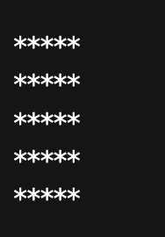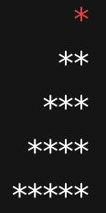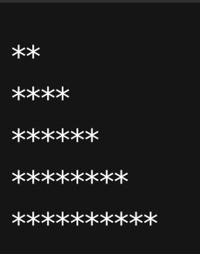

3.

Print

n

Stars

on

Same

Line

4.

Print

Square

of

Stars

(
n

x

n

Stars)

5.

Print

an

Increasing

Triangle

of

Stars

6.

Print

a

Right-Aligned

Triangle

of

Stars

7.

Print

Stars

in

Even

Numbers

(2
,

4
,

6
,

8
,

10)

8. Print Stars in Odd Numbers (1, 3, 5, 7, 9)
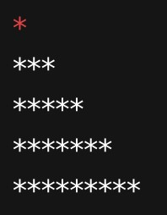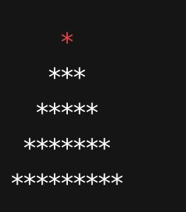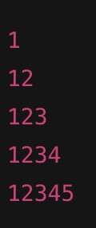

9.

Print

a

Centered

Pyramid

of

Stars

10.

Print

Stars

and

Spaces

Alternating

(
Stars

and

Blank

Spaces)

(
b

=

blank

space

here)

11.

Print

Numbers

in

an

Increasing

Sequence

(1
,

12
,

123
,

1234
,

12345)

12. Print Repeated Numbers per Row (Same Number Repeated)
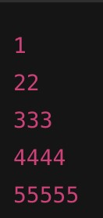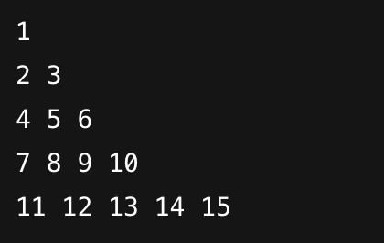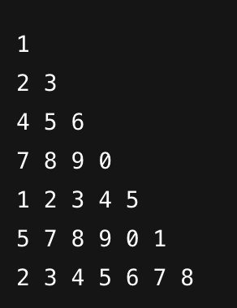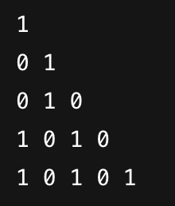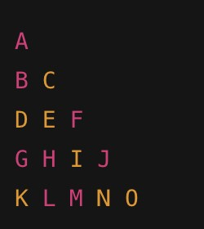

13.

14.

15.

16

17
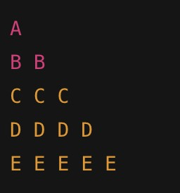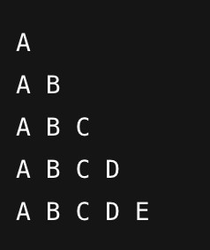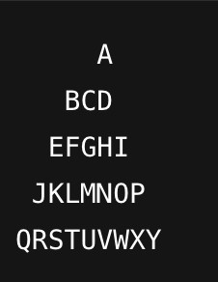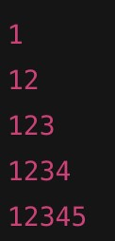

18.

19.

20.

21.
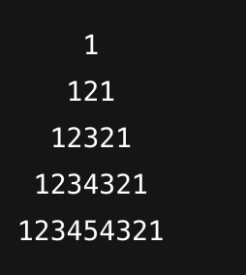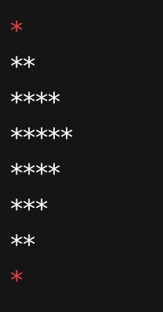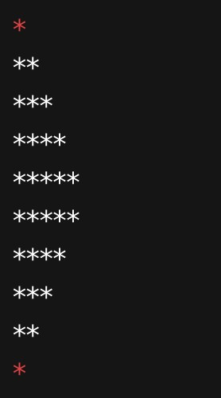
C

22.

23.

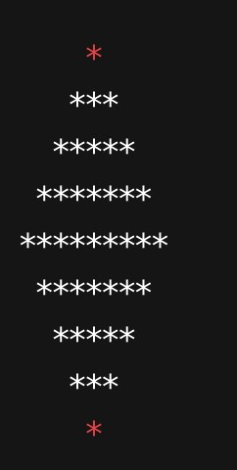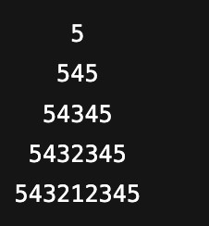

24

25.

